Build a Heap

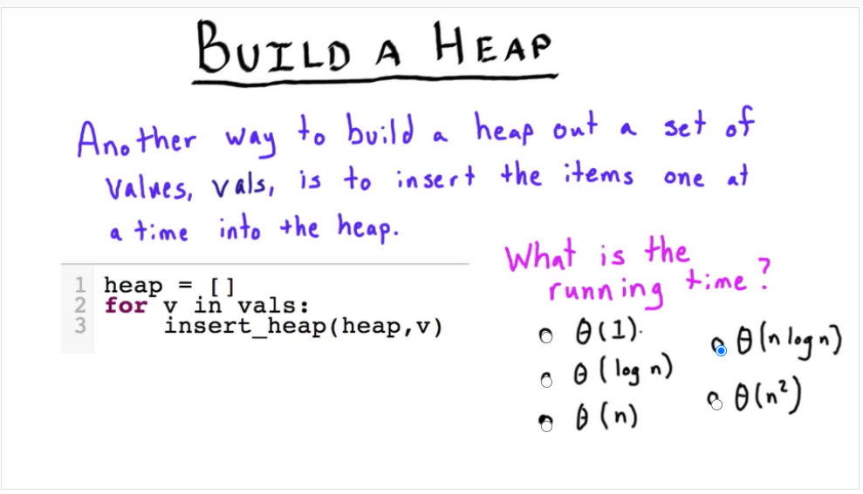

Minimize Sum of Absolute Value

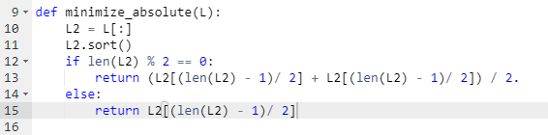

Minimize Sum of Squares

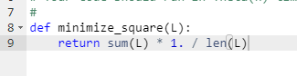

Mode

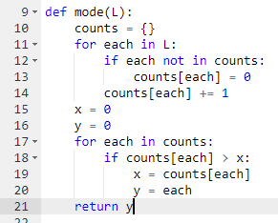

Up Heapify

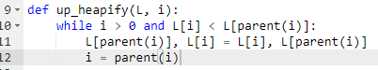

Actor Centrality

